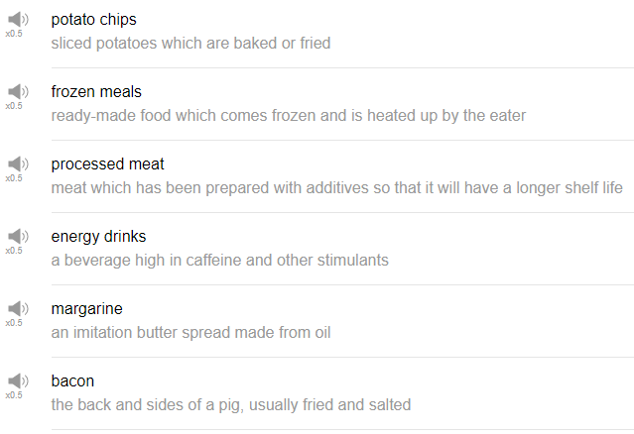

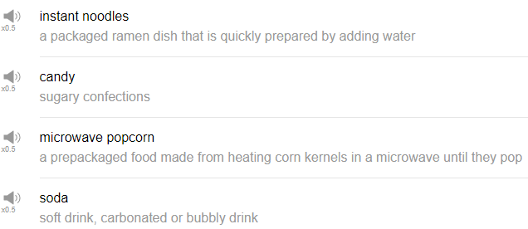

|  |
| --- |
| Hi everybody, my name is Alisha. Welcome back to Top Words. Today we're going to be talking about 10 foods that will kill you faster. Oh!! |
| 1. bacon |
| Bacon is delicious, it's usually thin or maybe slightly thicker strips of pork meat that you typically fry, or you can bake. Salt and fat. I eat bacon maybe once a month these days. |
| 2. candy |
| Candy, sweets, all the manufactured sugary sweet stuff. All of it is called candy. Candy is not good for you because it's just sugar; sugar and food coloring and spice, fructose, corn syrup. In a sentence, I try not to eat any candy but every once in a while I give in. |
| 3. energy drinks |
| Popular energy drinks are, let's see, Monster, Red Bull... Energy drinks are bad because of the caffeine, for one. Large amounts of caffeine, large amounts of sugar, often food coloring, and so on. Try to limit your consumption of energy drinks, too much can be very damaging to your health. |
| 4. frozen meals |
| It's an entire meal in a package and you can just put it in your oven, or put it in your microwave, heat it up, and your dinner or lunch or whatever is ready. Those frozen meals have a ton of salt, many many frozen meals use preservatives to keep whatever is in the package from going bad, from becoming rotten. In a sentence, I don't like eating frozen meals, i just don't think they taste good. |
| 5. instant noodles |
| Cup ramen is a very very popular brand of instant noodles, all you need to do is pour hot water over the dried noodles, and there's usually some kind of flavor pack, they're very very cheap and it's filling. So in a sentence, when I was in college I ate instant noodles every day, and I felt terrible. That's not true. |
| 6. margarine |
| The next word on this list is margarine. Margarine is very very similar to butter, it's used as a spread, a partially hydrogenated oil content of margarine is much higher than butter. If memory serves me correctly, this actually builds up in the body, your body just can't break it down, like, if you consume too much of this, it just hangs out in your body. In a sentence, in my family we use margarine every day when I was growing up. |
| 7. microwave popcorn |
| Microwave popcorn is popcorn that comes in a flat bag you just put it in the microwave and turn it on, and it pop pop pop, and you have microwave popcorn usually butter-flavored, maybe salt flavored, whatever, it's delicious. And you can eat it while you watch a movie, great fun. This is bad for you because there's butter and salt and oils on the inside of that bag and it has to be kept preserved, so there's a lot of salt content, there are also preservatives in that, but all of those things are not so good for you. Let's get some microwave popcorn at the supermarket for our movie later. |
| 8. potato chips |
| I love potato chips i'm a chip junkie, I love potato chips, but they are terrible for you. Carbs themselves are not bad, we need carbohydrates, of course, but potato chips are just empty, meaning they are nothing but carbohydrates, also potato chips are fried, which is so that's oil. There's also salt with potato chips, there might also be flavorings added to potato chips, salt and vinegar, I think, or sour cream and onion chips, there're barbecue chips, all these different flavorings are not natural, and you're eating them. I love potato chips even though i know they're terrible for you. |
| 9. processed meat |
| For example hotdogs, sandwich lunch meat, a lot of the meats that you see in the supermarket in a package, maybe it's shaped in a circle, or a hot dog, for example, wrapped in plastic like that. It's a combination of all of the leftover parts of an animal, ground together and then put into a tube or some other shape. Of course processed meat is often very convenient if you're busy or sometimes you just have a craving for a hot dog, it's easy to buy, easy to cook easy, easy to use. In a sentence, I try not to buy processed meat because when I eat it I feel bad. |
| 10. soda |
| Soda also contains food coloring, sugar, high fructose, corn syrup, things which are quite famous for breaking down teeth, so drinking a lot of soda can have a very very negative impact on your body as a whole, on your digestive system as a whole. And it can affect your skin, many people have sugar sensitive skin, so if someone who drinks a lot of soda, for some people, they may have a lot of acne, as a result of their sugar intake. |
| So that's the end of 10 foods that may kill you faster. Oh no! Some some of my favorite foods like bacon were on that list, and potato chips. Oh no! but if you have a food that you just love but that you know is terrible for you, share it with us, leave in the comments. If you haven't already, please make sure to subscribe to our Channel and we will see you again next time for some more fun stuff thanks very much for watching, Bye! |